Project Design Phase-II
Data Flow Diagram & User Stories

Date | 31 January 2025
Team ID
Project Name
Maximum Marks | 4 Marks

Data Flow Diagrams:
A Data Flow Diagram (DFD) is a traditional visual representation of the information flows within a system. A neat and clear DFD for Blog Nest can depict the right amount of system requirements graphically. It shows how data enters and leaves the Blog Nest system, how blog information is processed, and where user details, blog posts, comments, and other data are stored.

Example:

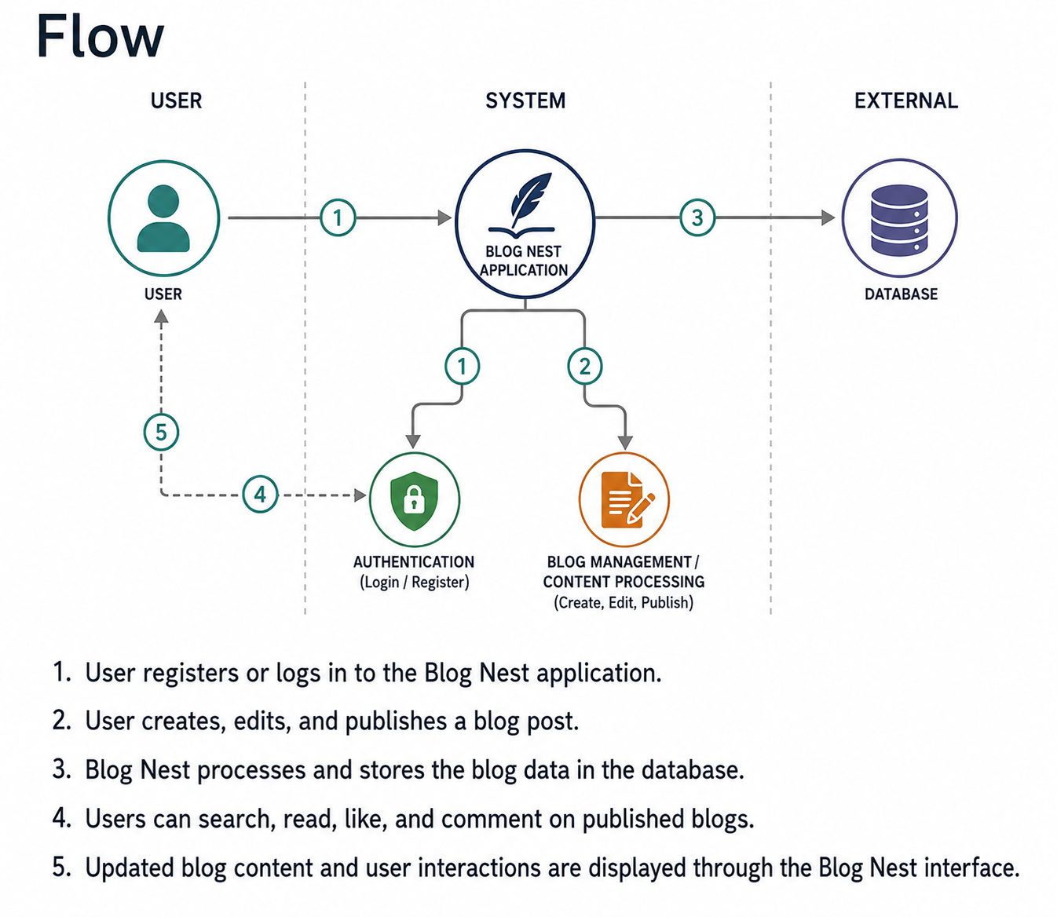

Example: DFD Level 0 (Industry Standard)
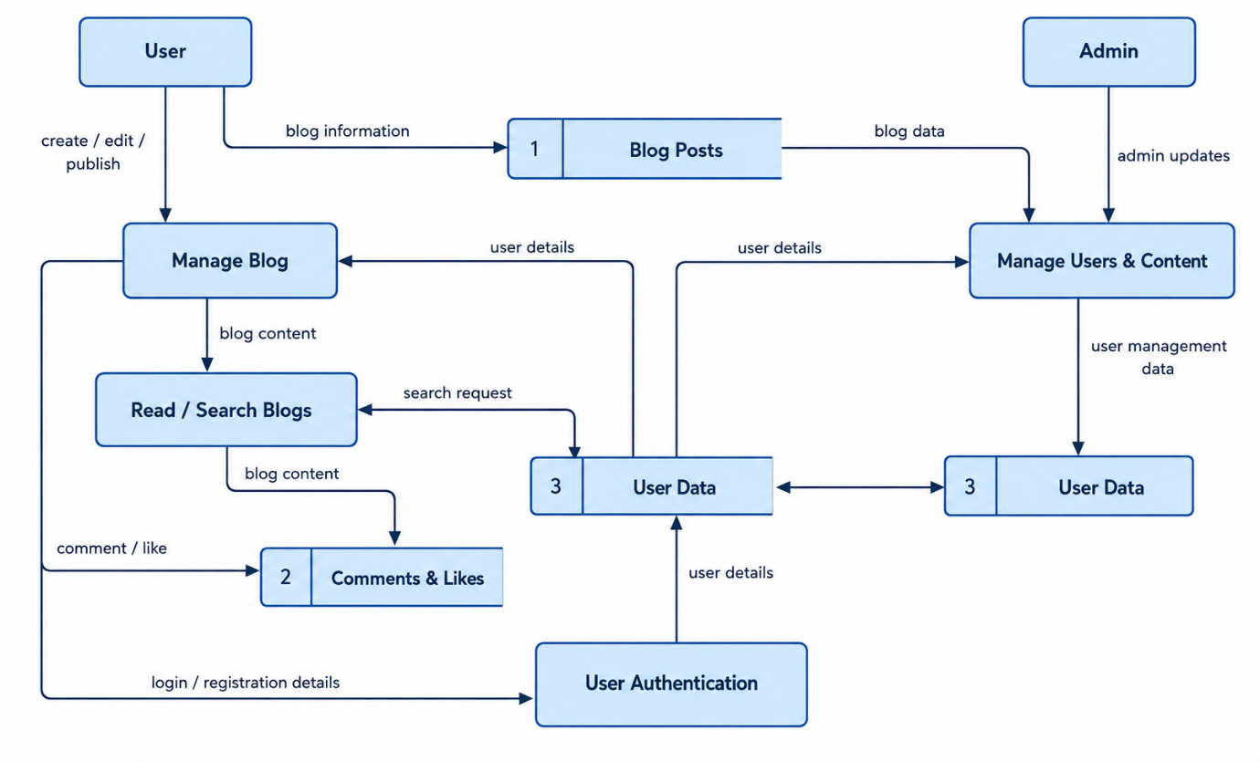

User Stories:
Use the below template to list all the user stories for the product.
User Type | Functional Requirement (Epic) | User Story Number | User Story / Task | Acceptance Criteria | Priority | Release
Customer (Web User) | Registration | USN-1 | As a user, I can register for Blog Nest by entering my name, email, password, and confirming my password. | I can successfully create an account and access my dashboard. | High | Sprint-1
Customer (Web User) | Registration | USN-2 | As a user, I will receive a confirmation message once I have registered for Blog Nest. | I can receive the confirmation message after registration. | High | Sprint-1
Customer (Web User) | Registration | USN-3 | As a user, I can register for Blog Nest through Facebook. | I can register and access my dashboard using Facebook login. | Low | Sprint-2
Customer (Web User) | Registration | USN-4 | As a user, I can register for Blog Nest through Gmail. | I can register and access my dashboard using Gmail login. | Medium | Sprint-1
Customer (Web User) | Login | USN-5 | As a user, I can log into Blog Nest by entering my email and password. | I can successfully log in and access my account. | High | Sprint-1
Customer (Web User) | Dashboard | USN-6 | As a user, I can view my Blog Nest dashboard after logging in. | I can view my profile and available blog options. | High | Sprint-1
Customer (Web User) | Blog Management | USN-7 | As a user, I can create and write a new blog post. | I can enter a title and content and save the blog post. | High | Sprint-2
Customer (Web User) | Blog Management | USN-8 | As a user, I can edit my existing blog posts. | I can update the content and save the changes successfully. | High | Sprint-2
Customer (Web User) | Blog Management | USN-9 | As a user, I can delete my blog posts. | I can delete a selected blog post successfully. | Medium | Sprint-2
Customer (Web User) | Blog Publishing | USN-10 | As a user, I can publish my blog post. | The blog becomes available for other users to read. | High | Sprint-2
Customer (Web User) | Blog Viewing | USN-11 | As a user, I can read published blogs. | I can open and read the complete blog content. | High | Sprint-3
Customer (Web User) | Blog Search | USN-12 | As a user, I can search for blogs using keywords or titles. | Relevant blogs are displayed based on my search. | Medium | Sprint-3
Customer (Web User) | Interaction | USN-13 | As a user, I can like and comment on blog posts. | My like or comment is successfully added to the blog. | High | Sprint-3
Customer (Web User) | Profile | USN-14 | As a user, I can view and update my profile information. | My updated profile information is saved successfully. | Medium | Sprint-4
Administrator | User Management | USN-15 | As an administrator, I can manage registered users. | I can view, update, or remove user accounts when required. | High | Sprint-4
Administrator | Blog Management | USN-16 | As an administrator, I can manage blog posts published on Blog Nest. | I can view, edit, or remove inappropriate blog posts. | High | Sprint-4
Administrator | Category Management | USN-17 | As an administrator, I can manage blog categories. | I can add, edit, or delete blog categories. | Medium | Sprint-4

